**Lab 3**

**Fourier series, Fourier transform and Bode Plots in MATLAB**

**EECS3451**

**Name: Chethana Wickramasinghe**

**Student Number: 214866511**

**Professor: Peter Lian**

**13th of March 2021**

**1. Introduction:**

Using MATLAB to answer questions provided. Questions leads to plot periodic signals with Fourier series representation, obtain and plot the output response signal with a periodic input signal and to learn and create plots for the frequency response of a system (i.e. Bode plot) in MATALB. This report is mainly answering the provided questions using MATLAB. Results will demonstrate the use of MATLAB properly in analysing signals and systems.

**2. Equipment:** MATLAB

**3. Results and discussion:**

# 1. Periodic signals with Fourier series representation

## Laboratory Exercise 1

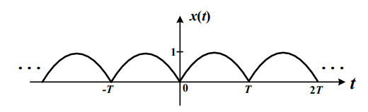Consider the following periodic signal x(t), which is a full-wave rectified sine-wave as shown in figure.

1. Determine the Fourier coefficients of x(t)

$x\left(t\right)=\left|\sin\left(ωot\right)\right| , ωo= π/T$

$a0=\frac{1}{To}\int_{0}^{T}{\sin\left(ωot\right)dt} =\frac{1}{To} \left(-\frac{\cos\left(ωoT\right)}{ωo}+\frac{1}{ωo}\right)= \frac{1}{T} \left(-\frac{\operatorname{Tcos}\left(π\right)}{π}+\frac{T}{π}\right)=\frac{1-\cos\left(π\right)}{π}=\frac{2}{π}$

$an= \frac{2}{To}\int_{0}^{T}{\sin\left(ωot\right)\cos\left(nωot\right)dt}$

$$=\frac{2}{T}\frac{\left(-\left(n-1\right)\cos\left(\left(n+1\right)Tωo\right)—\left(-n-1\right)\cos\left(\left(1-n\right)Tωo\right)-2\right)}{\left(2n^{2}-2\right)ωo}$$

$$=\frac{\left(-\left(n-1\right)\cos\left(\left(n+1\right)π\right)—\left(-n-1\right)\cos\left(\left(1-n\right)π\right)-2\right)}{(n^{2}-1)π}$$

simplify

$bn= \frac{2}{To}\int_{0}^{T}{\sin\left(ωot\right)\sin\left(nωot\right)dt}$

$$=\frac{2}{T}\frac{\left(-\left(n-1\right)\sin\left(\left(n+1\right)Tωo\right)—\left(n+1\right)\sin\left(\left(1-n\right)Tωo\right)\right)}{\left(2n^{2}-2\right)ωo}$$

$$=\frac{\left(-\left(n-1\right)\sin\left(\left(n+1\right)π\right)—\left(n+1\right)\sin\left(\left(1-n\right)π\right)\right)}{(n^{2}-1)π}=0$$

1. Plot x(t) in MATALB that considers the first 40 terms in the Fourier series if T = 2 seconds. Plot x(t) for -4 ≤ t ≤ 4. [Note: you should not simply enter term by term in MATLAB to complete the plot]

$x\left(t\right)=ao+ \sum_{n=1}^{∞}{[an\cos\left(\frac{2πnt}{3}\right)+bn\sin\left(\frac{2πnt}{3}\right) ]}$

syms t

T = 2;

sum = 0;

x = abs(sin(pi*t/T));

a0=2/pi;

for n=1:40

an=(2/T).*int(x.*cos(n*t*pi/T),t,0,T);

bn=0;

sum=sum+(an.*cos(n*t*pi/T)+bn.*sin(n*t*pi/T));

end

xt = a0 + sum;

fplot(xt, [-4,4]);

xlabel('Time');

ylabel('x(t)');

title('x(t) that considers the first 40 terms in the Fourier series');

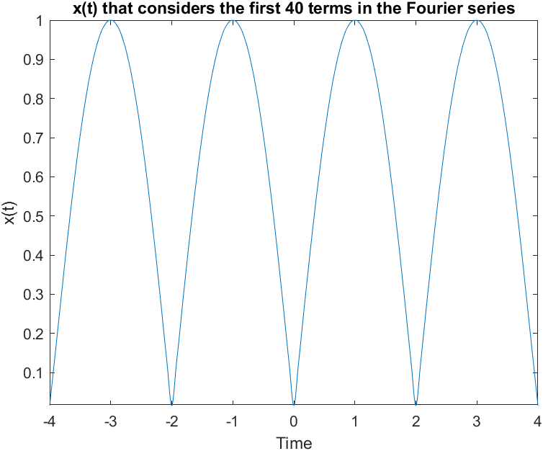

1. Based on the Fourier coefficients, if T = 2 seconds, plot both the magnitude spectrum and phase spectrum of x(t) as a function of n for -10 ≤ n ≤ 10 in MATLAB. Use MATLAB built-in function stem()to plot all the points in both plots. Use subplot() to plot the magnitude spectrum in the upper plot and the phase spectrum in the lower plot. Label both plots.

t = -4:0.01:4;

x = abs(sin(pi*t/T));

test = fft(x);

%exponeentail

subplot(2,1,1); %2 rows, 1 column, 1st spot

stem(t,abs(test))

xlabel('n');

ylabel('x(t)');

title('Magnitude Spectrum');

subplot(2,1,2); %2 rows, 1 column, 1st spot

stem(t,angle(test)*180/pi) %radians

xlabel('n');

ylabel('x(t)');

title('Phase Spectrum');

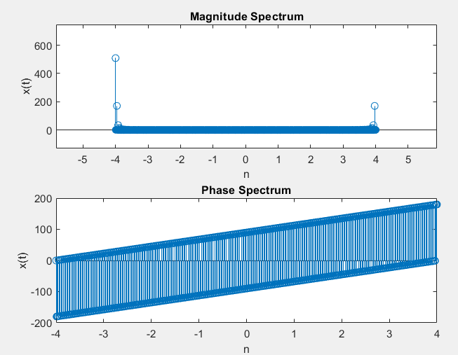

1. x(t) is now an input signal for an LTIC system with impulse response h(t), and the Fourier

transform of h(t) in this system is: $H\left(ω\right)=\frac{10}{30.5+jω}$. Determine the output response

signal y(t). Plot both x(t) and the output signal y(t) on the same graph. Plot a few cycles.

$H\left(ω\right)=\frac{Y\left(ω\right)}{X\left(ω\right)}= \frac{10}{30.5+jω}$

$Y\left(ω\right)\left(30.5+jω\right)=10 X\left(ω\right)$

$jω Y\left(ω\right)+30.5 Y\left(ω\right)=10 X\left(ω\right)$

$\frac{dy\left(t\right)}{dt}+30.5 y\left(t\right)=10 x(t)$

x = abs(sin(pi*t/T));

fplot(x, [-10,20]);

xlabel('t');

hold on;

syms y(t)

T = 2;

eqn = diff(y,t) + 30.5*y == 10.*x;

Dy = diff(y,t);

cond = [y(0)== 5];

f = dsolve(eqn,cond);

fplot(f, [-10,20])

xlabel('t');

ylim([-1 2])

legend('x(t)','y(t)');

hold off;

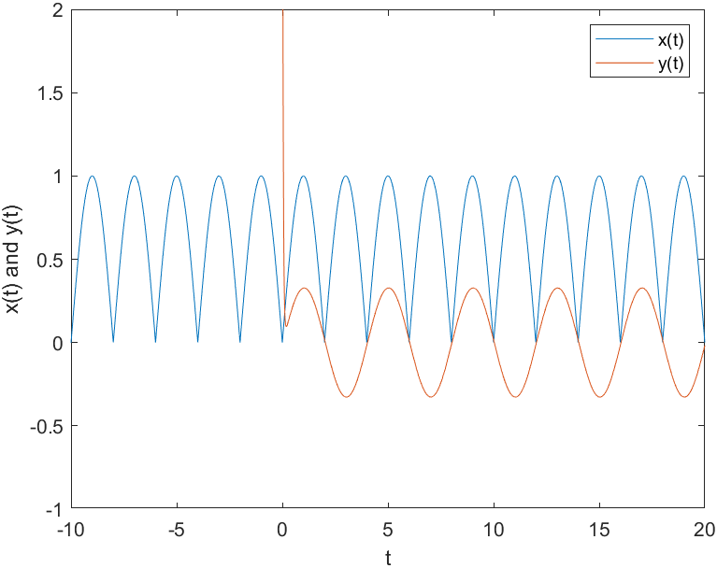ylabel('x(t) and y(t)');

## Laboratory Exercise 2

1. 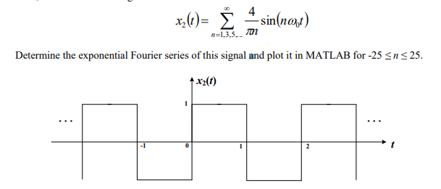Consider a symmetrical square wave signal x2(t) with an amplitude of 1 and a fundamental period of T0, the Fourier series is given as:

$To=2, ωo=\frac{2π}{To}=\frac{2π}{2}= π$

$Dn=\frac{1}{To}\int{x\left(t\right)e^{-jnωot}dt }$

$=\frac{1}{2} \int_{0}^{1}{e^{-jnωot}dt}-\frac{1}{2} \int_{1}^{2}{e^{-jnωot}dt}$

$=\frac{1}{2}*\frac{1}{jnωo} \left(1-e^{-jnωo}\right)-\frac{1}{2}*\frac{e^{-2jnωo}}{jnωo}\left(e^{-jnωo}-1\right)$

$=\frac{1}{2jnωo}*\frac{\left(e^{-jnωo}\right)}{2jnω0}-\frac{e^{-jnωo}}{2jnωo}*\frac{e^{-2jnωo}}{2jnωo}$

$=\frac{1}{2jnωo}(1-2e^{-jnωo}+e^{-2jnωo}$)

$x\left(t\right)= \sum_{n=-25}^{25}{Dn e^{jnωot}}$

t = -10:0.001:10;

xt = 0*t;

for n=-25:25

if(n==0) % skip the zeroth term

continue;

end;

dn = (1/(2*i*n*pi)) .* (1- 2*exp(-j*n*pi) + exp(-2*j*n*pi)) ;

xt = xt + dn .* exp(j*n*pi*t) ;

end

plot(t, xt);

xlabel('t');

ylabel('x(t)');

title('Exponential Fourier series');

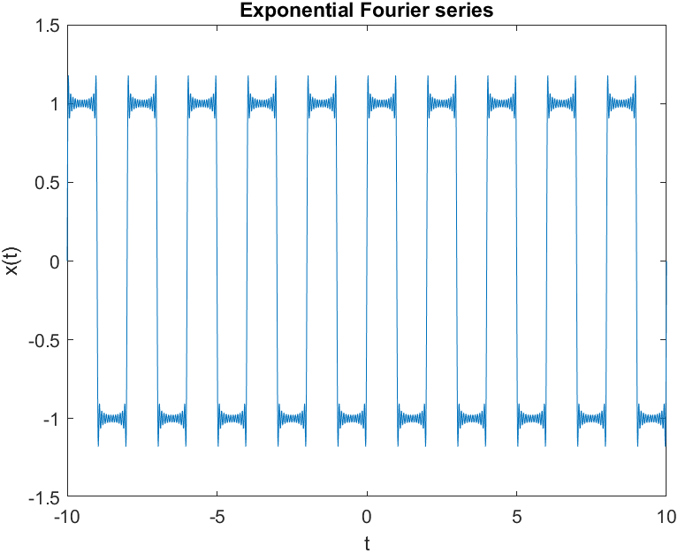

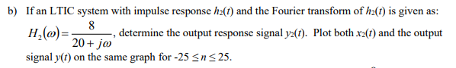

t = -10:0.01:10;

ht = 8* exp(-20*t) .* heaviside(t);

xt = 0*t;

for n=-25:25

if(n==0) % skip the zeroth term

continue;

end;

dn = (1/(2*i*n*pi)) .* (1- 2*exp(-j*n*pi) + exp(-2*j*n*pi)) ;

xt = xt + dn .* exp(j*n*pi*t) ;

end

plot(t, ht)

hold on;

yt = conv(xt, ht);

plot(t, yt(1:length(t)));

hold on;

plot(t, xt);

xlabel('t');

legend('h2(t)', 'y2(t)', 'x2(t)');

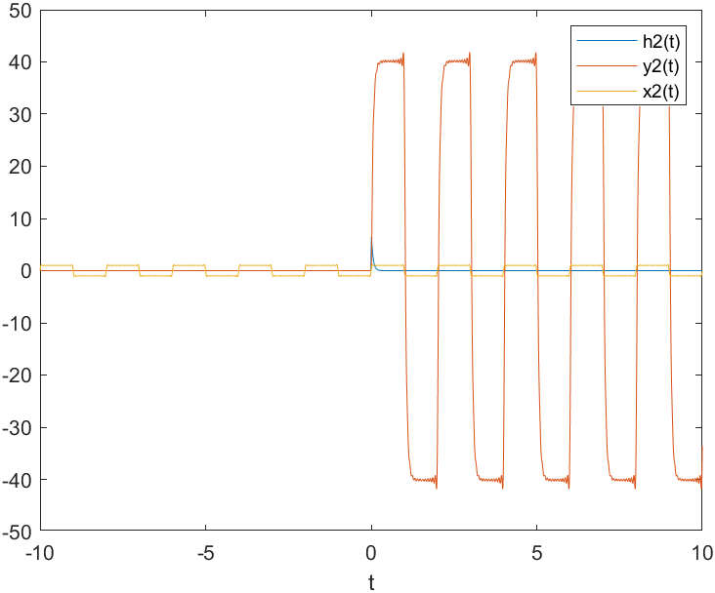hold off;

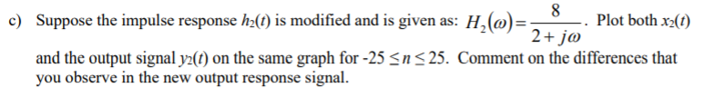

t = -10:0.01:10;

ht = 8* exp(-2*t) .* heaviside(t);

xt = 0*t;

for n=-25:25

if(n==0) % skip the zeroth term

continue;

end;

dn = (1/(2*i*n*pi)) .* (1- 2*exp(-j*n*pi) + exp(-2*j*n*pi)) ;

xt = xt + dn .* exp(j*n*pi*t) ;

end

plot(t, ht)

hold on;

yt = conv(xt, ht);

plot(t, yt(1:length(t)));

hold on;

plot(t, xt);

xlabel('t');

legend('h2(t)', 'y2(t)', 'x2(t)');

hold off;

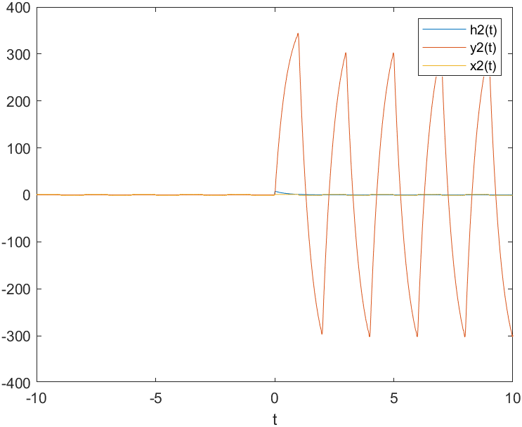

Extra

If $H\left(ω\right)=\frac{8}{0.5+jω}$

t = -10:0.01:10;

ht = 8* exp(-0.5*t) .* heaviside(t);

xt = 0*t;

for n=-25:25

if(n==0) % skip the zeroth term

continue;

end;

dn = (1/(2*i*n*pi)) .* (1- 2*exp(-j*n*pi) + exp(-2*j*n*pi)) ;

xt = xt + dn .* exp(j*n*pi*t) ;

end

plot(t, ht)

hold on;

yt = conv(xt, ht);

plot(t, yt(1:length(t)));

hold on;

plot(t, xt);

xlabel('t');

legend('h2(t)', 'y2(t)', 'x2(t)');

hold off;

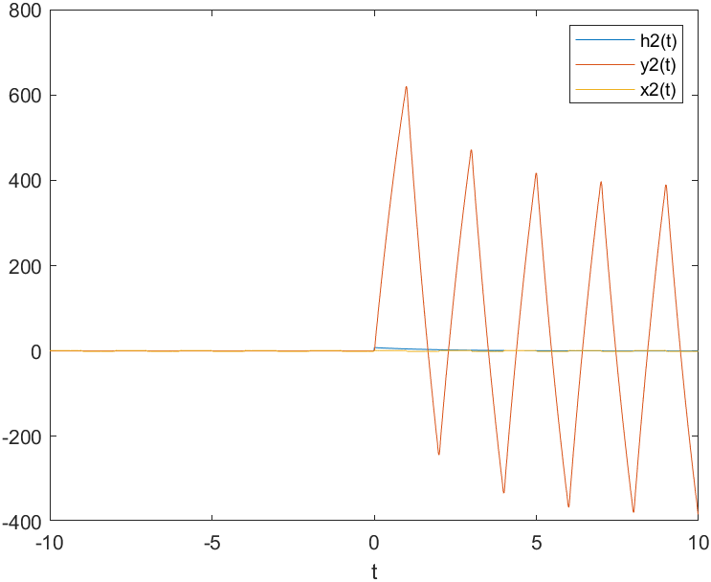

Observation

$H\left(ω\right)=\frac{8}{0.5+jω}$-> $H\left(ω\right)=\frac{8}{2+jω}$-> $H\left(ω\right)=\frac{8}{20+jω}$

Along to the right the output response graph y(t) gets more and more stretched along the y axis.

# 2. Creating Bode plots (i.e. gain and phase responses) in MATLAB

## Laboratory Exercise 3



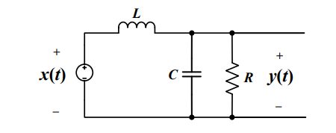

KCL at the red dot,

$\frac{1}{L}\int{y\left(t\right)-x\left(t\right)dt }+\frac{y\left(t\right)}{R}+\frac{Cdy(t)}{dt}=0$

Reduced to,

$\frac{y\left(t\right)}{L}-\frac{x\left(t\right)}{L}+\frac{dy\left(t\right)}{R dt}+C\frac{d^{2}y\left(t\right)}{dt}=0$

$\frac{y\left(t\right)}{L}+\frac{dy\left(t\right)}{R dt}+C\frac{d^{2}y\left(t\right)}{dt}=\frac{x\left(t\right)}{L}$

$y(t)+\frac{L dy\left(t\right)}{R dt}+CL\frac{d^{2}y\left(t\right)}{dt}=x(t)$

$\frac{y\left(t\right)}{CL}+\frac{ dy\left(t\right)}{RC dt}+\frac{d^{2}y\left(t\right)}{dt}=\frac{x\left(t\right)}{CL}$

R = 2, L = 1e-3 H , C= 10e-6 F

$\frac{d^{2}y\left(t\right)}{dt} +\frac{ dy\left(t\right)}{(10e-6 *2) dt}+\frac{y\left(t\right)}{(10e-6 * 1e-3)}=\frac{x\left(t\right)}{(10e-6 * 1e-3)}$

$\frac{d^{2}y\left(t\right)}{dt} +\frac{ dy\left(t\right)}{(2e-5) dt}+\frac{y\left(t\right)}{(10e-9)}=\frac{x\left(t\right)}{(10e-9)}$

${[\left(jω\right)}^{2} +5e4jω+{10}^{8}]Y\left(ω\right)={10}^{8}X(ω)$

$H\left(ω\right)=\frac{Y\left(ω\right)}{X\left(ω\right)}=\frac{{10}^{8}}{{[\left(jω\right)}^{2} +5e4jω+{10}^{8}]}$

(s = jω)

$H\left(s\right)=\frac{{10}^{8}}{s^{2} +5e4s+{10}^{8}}$

Method1

num_coeff = [100000000]; % coefficients of the numerator

% in decreasing powers of s

denom_coeff = [1 50000 100000000]; % coefficient of the denominator

% in decreasing powers of s

sys = tf(num_coeff,denom_coeff) ;

% specify the transfer function

bode(sys,{0.01,100000000}); % sketch the Bode plots

Method2

L= 1e-3;

C=10e-6;

R =2;

sys = tf(1, [L*C L/R 1]);

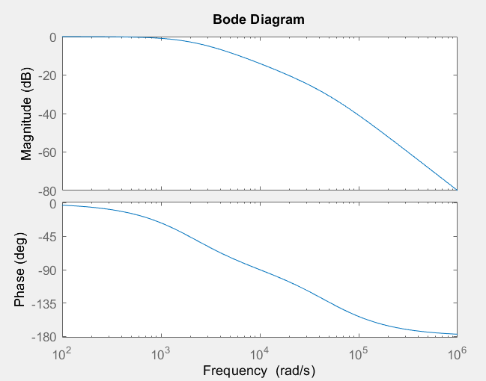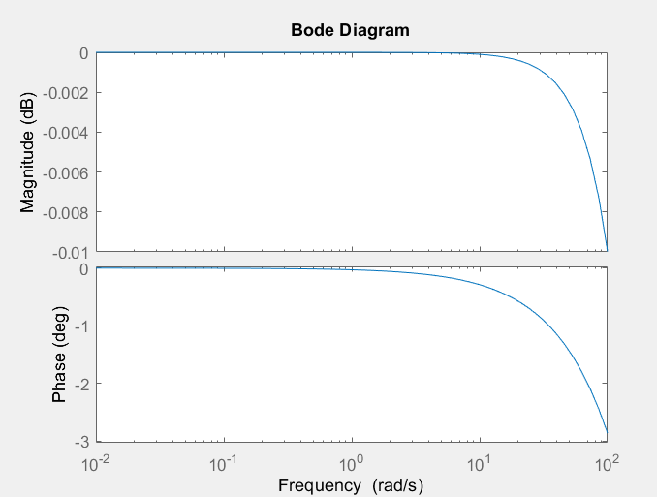bode(sys);

With longer ranges for Y and X axis

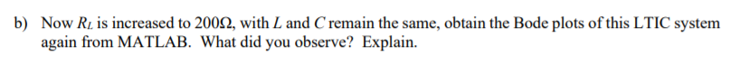

R = 200, L = 1e-3 H , C= 10e-6 F

$\frac{d^{2}y\left(t\right)}{dt} +\frac{ dy\left(t\right)}{(10e-6 *200) dt}+\frac{y\left(t\right)}{(10e-6 * 1e-3)}=\frac{x\left(t\right)}{(10e-6 * 1e-3)}$

$\frac{d^{2}y\left(t\right)}{dt} +\frac{ dy\left(t\right)}{(2e-3) dt}+\frac{y\left(t\right)}{(10e-9)}=\frac{x\left(t\right)}{(10e-9)}$

${[\left(jω\right)}^{2} +500jω+{10}^{8}]Y\left(ω\right)={10}^{8}X(ω)$

$H\left(ω\right)=\frac{Y\left(ω\right)}{X\left(ω\right)}=\frac{{10}^{8}}{{[\left(jω\right)}^{2} +500jω+{10}^{8}]}$

(s = jω)

$H\left(s\right)=\frac{{10}^{8}}{s^{2} +500s+{10}^{8}}$

Method1

clear; % clear the MATLAB environment

num_coeff = [100000000]; % coefficients of the numerator

% in decreasing powers of s

denom_coeff = [1 500 100000000]; % coefficient of the denominator

% in decreasing powers of s

sys = tf(num_coeff,denom_coeff);

% specify the transfer function

bode(sys,{0.01,100000000}); % sketch the Bode plots

Method2

L= 1e-3;

C=10e-6;

R =200;

sys = tf(1, [L*C L/R 1]);

bode(sys);

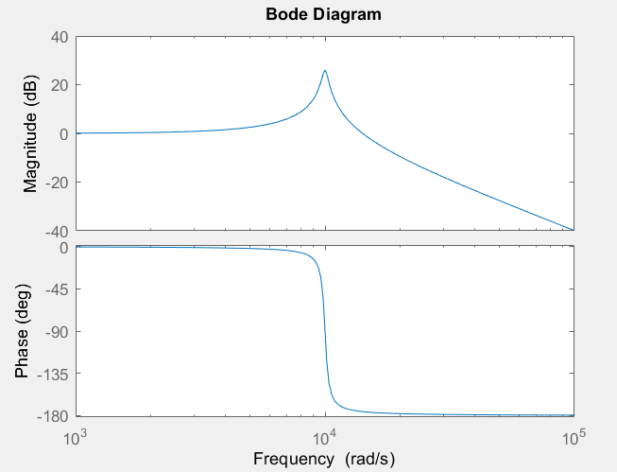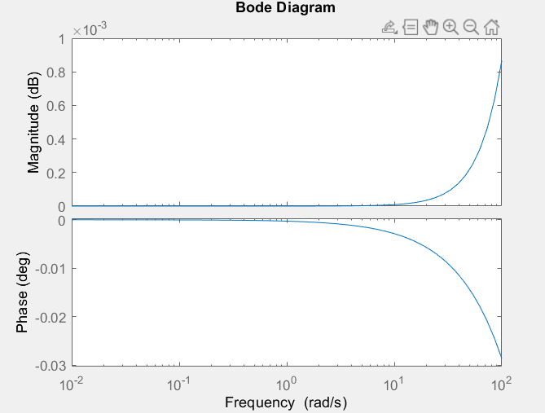

With longer ranges for Y and X axis

**Observations:**

When R value increased to 200, the magnitude has a spike in positive values while the phase remains in negative values but is compressed along the x-axis.

This is because, R= 2 has more phase margin and more stable than when R increase to 200.

**Extra**

R = 0.2, L = 1e-3 H , C= 10e-6 F

$\frac{d^{2}y\left(t\right)}{dt} +\frac{ dy\left(t\right)}{(10e-6 *0.2) dt}+\frac{y\left(t\right)}{(10e-6 * 1e-3)}=\frac{x\left(t\right)}{(10e-6 * 1e-3)}$

$\frac{d^{2}y\left(t\right)}{dt} +\frac{ dy\left(t\right)}{(2e-6) dt}+\frac{y\left(t\right)}{(10e-9)}=\frac{x\left(t\right)}{(10e-9)}$

${[\left(jω\right)}^{2} +5e5jω+{10}^{8}]Y\left(ω\right)={10}^{8}X(ω)$

$H\left(ω\right)=\frac{Y\left(ω\right)}{X\left(ω\right)}=\frac{{10}^{8}}{{[\left(jω\right)}^{2} +5e5jω+{10}^{8}]}$

(s = jω)

$H\left(s\right)=\frac{{10}^{8}}{s^{2} +5e5s+{10}^{8}}$

clear; % clear the MATLAB environment

num_coeff = [100000000]; % coefficients of the numerator

% in decreasing powers of s

denom_coeff = [1 500000 100000000]; % coefficient of the denominator

% in decreasing powers of s

sys = tf(num_coeff,denom_coeff);

% specify the transfer function

bode(sys,{0.01,100000000}); % sketch the Bode plots

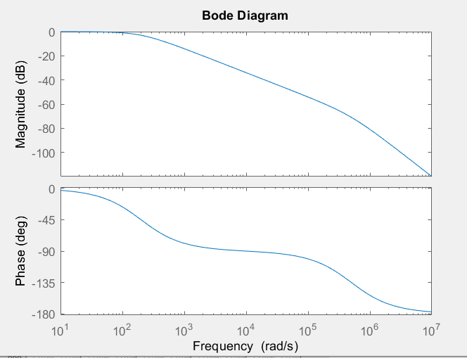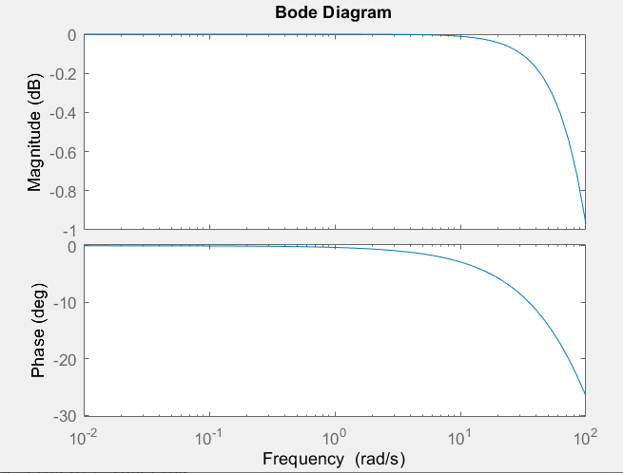

With longer ranges for Y and X axis

**Observations:**

When R value decreased to 0.2, the magnitude flipped and now has positive values while the phase remains in negative values but is less compressed along the x-axis.

This is because, R= 0.2 has more phase margin and more stable than when R increase 2 and then 200.

**4. Conclusion: state what you learn from this lab, lab objectives you achieved, and any difficulties you met.**

Learned how to plot periodic signals with Fourier series representation, plot the output response signal with a periodic input signal and use Bode plot in MATALB.

All the questions were answered using MATLAB and was able to get a better understanding of Fourier series plots and response signal plots by observing the generated graphs using MATLAB.

Had a hard time plotting Trigonometric Fourier series and Exponential Fourier series. Understanding the gain and response plots were challenging.